Advanced Data Mining & Predictive Modelling
Section 2 – Group 8
Name | ID
Sachita Gupta | FT262066
Kuntal Pyne | FT262019
Swapnil | FT263019
Raghav Sharma | FT261038
Tabish Hakim | FT264080
Darshan Patil | FT262048
Darshan Ostwal | FT263073
Tarunya | FT264030

Group Assignment Report
Comparing Binary Classification Models (Decision Tree vs Logistic Regression) on the UCI Bank Marketing Dataset.
1. Objective
This exercise aims to clean and prepare the Bank Marketing dataset for machine learning, then build, tune, and evaluate two binary classifiers—Decision Tree and Logistic Regression. Both use the same train-test split and are evaluated on predicting term deposit subscriptions, focusing on maximizing TPR while minimizing FPR. The analysis highlights the precision–recall trade-off and the importance of threshold optimization in improving real-world business decisions.
2. Version of Library Used
- Python: 3.12.12
- Pandas: 2.2.2
- NumPy: 2.0.2
- Scikit-learn: 1.6.1
Additional libraries, including Matplotlib and Seaborn were employed.
3. Acknowledgement and Data Source
The Bank Marketing Dataset (bank-additional-full.csv), sourced from the UCI Machine Learning Repository (Moro et al., 2014), was selected from four available versions for its detailed records of a Portuguese bank’s direct marketing campaigns, aimed at predicting whether a client subscribes to a term deposit.
4. Meta Information about Data
- Dataset Overview: Contains 45,211 records and 17 features initially, reduced to 13 after dropping high-missing-value columns.
- Target Details: Binary target variable ‘y’ (1 = subscribed, 0 = not subscribed) with a positive class rate of ~11%, indicating imbalance.
- Data Structure: Includes 7 numeric, 6 categorical, and 1 binary target feature, split 70% for training and 30% for testing using stratified sampling.
Feature | Type | Missing/Unknown (%) | Remarks
contact | Categorical | 28.80 | Dropped
poutcome | Categorical | 81.75 | Dropped
job | Categorical | 0.64 | Imputed (mode)
education | Categorical | 4.11 | Imputed (mode)
balance | Numerical | 0 | Outliers present
5. Challenges faced with the data
- Contact (28.80%) and poutcome (81.75%) contain many unknown entries, which can introduce bias and reduce model reliability.
- The dataset includes both categorical and numerical features, requiring appropriate encoding and scaling for model compatibility.
- The balance feature (−8,019 to 102,127) shows extreme outliers that can distort training and affect model performance.
- Missing values may introduce bias and weaken generalization, so the duration variable was excluded to avoid temporal bias, as it is known only after customer contact.
6. Strategies to overcome the challenges
- Contact (28.80%) and poutcome (81.75%) were dropped due to excessive unknowns, while job (0.64%) and education (4.11%) were imputed with the mode to maintain data consistency.
- Categorical variables were one-hot encoded (drop='first'), numerical features standardized using StandardScaler, and ordinal variables like education could use label encoding.
- The target variable y was encoded as 1 for “yes” and 0 for “no” to enable binary classification.
- The dataset was split into 70% training and 30% testing sets using random_state=42 for reproducibility.
7. Class level metrics of the two models
The metrics found through the analysis of the Test Set with each model’s threshold set to optimal levels (found by maximising Youden’s J, TPR-FPR) are listed below:
1. Decision tree
Tuned model:
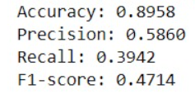
Untuned model:
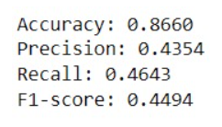
2. Logistic Regression
Tuned model:
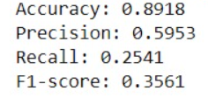
Untuned model:
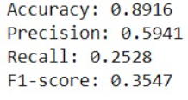
Decision tree : Before Tuning
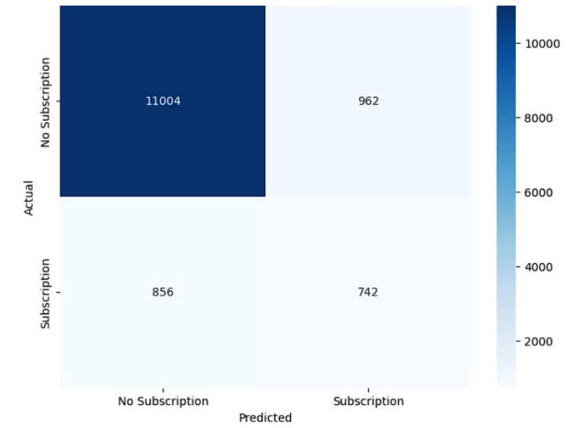
Decision tree : After Tuning
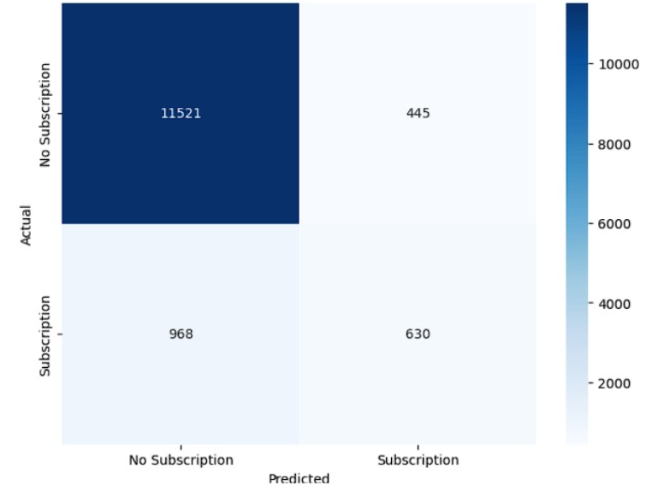
Logistic regression : Before Tuning
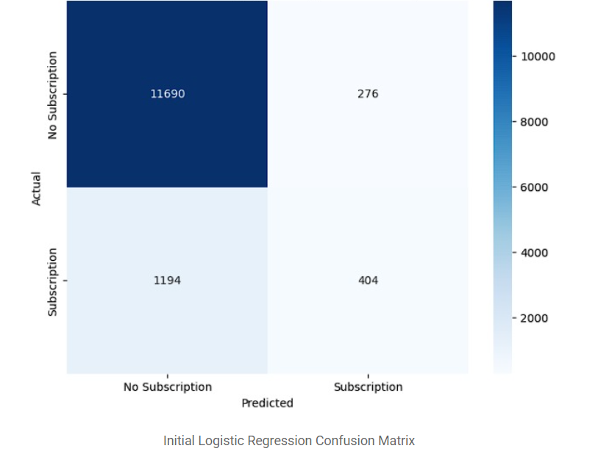
Logistic regression : After Tuning
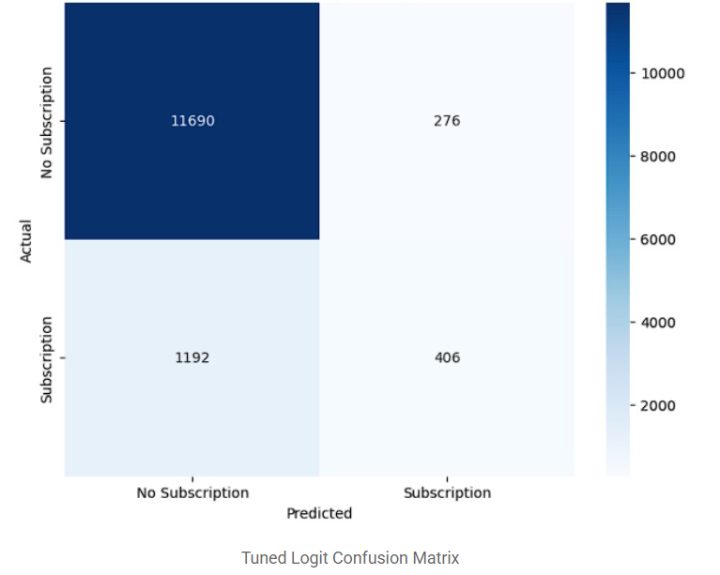
8. Best TPR and FPR for both models
Logistic Regression:
- Best Threshold: 0.1106
- Best TPR (Sensitivity): 0.8323
- Corresponding FPR: 0.1948
Decision Tree:
- Best Threshold: 0.1250
- Best TPR (Sensitivity): 0.7991
- Corresponding FPR: 0.1900
9. Corresponding TPR and FPR for the best threshold
- Logistic Regression: Optimal threshold 0.1106, TPR = 0.8323, FPR = 0.1948 — high subscriber detection with moderate false positives, ideal for marketing.
- Decision Tree: Optimal threshold 0.1556, TPR = 0.1008, FPR = 0.0154 — low detection and limited practical value.
Thresholds were found using .predict_proba(), by testing values from 0 to 1 and selecting the point that gave the best TPR while keeping FPR reasonably low.
10. Findings from the AUC analysis of the two algorithms
The AUC summarizes model performance across thresholds, with Logistic Regression (0.8884) outperforming the Decision Tree (0.8736) by correctly ranking positives 88.84% of the time. At optimal thresholds, the Decision Tree (0.1556) achieves TPR = 0.1008, FPR = 0.0154, while Logistic Regression (0.1106) attains TPR = 0.8323, FPR = 0.1948, showing a stronger trade-off.
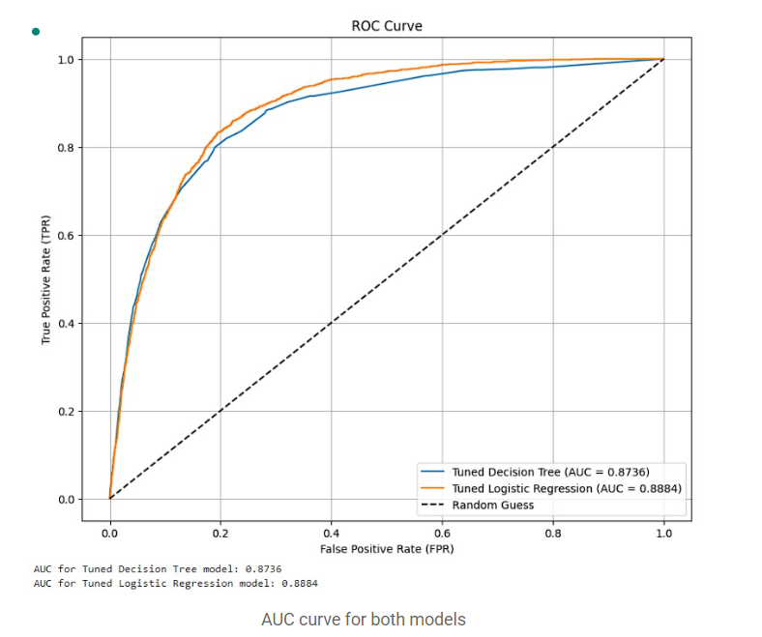
11. Conclusion and Recommendations
Conclusion
Both models performed well, but Logistic Regression outperforms the Decision Tree, achieving an AUC of 0.8884 vs. 0.8736 and identifying 83.23% of subscribers with 19.48% FPR, compared to the Decision Tree’s 10.08% TPR and 1.54% FPR.
Recommendations
- Model Deployment: Use the Logistic Regression model to target clients most likely to subscribe to a term deposit.
- Threshold Implementation: Apply the optimal threshold of 0.1106 (TPR = 0.8323, FPR = 0.1948) to maximize genuine reach while minimizing false outreach.
- Future Work: Explore ensemble models (Random Forest, Gradient Boosting) to reduce overfitting and apply feature selection (correlation or information gain) to enhance interpretability.

